**Z-test for One Sample**

Procedure:

1. State the claim mathematically and verbally. Identify the null and alternative hypotheses.

2. Specify the level of significance.

3. Sketch the sampling distribution.

4. Determine the critical value(s).

5. Determine the rejection regions(s).

6. Find the standardized test statistic.

7. Make a decision to reject or fail to reject the null hypothesis.

8. Interpret the decision in the context of the original claim.

Question:

Among the Top Batsmen in T20WC (2007-2021), in a Sample of 30 Batsmen, the average matches played by an Individual is equal to the Average matches played by all 49 Batsmen in the Population. Is there enough evidence to support this claim at α = 0.05?

Answer:

Ho (Null Hypothesis): Sample mean population (Matches played by top 30 batsman) is equal to the Population mean population (Matches played by all 49 Batsman)

H1: Matches played is different

Output:

Sample Data (Matches):

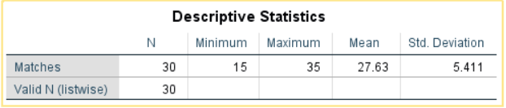

Population Data (Matches):

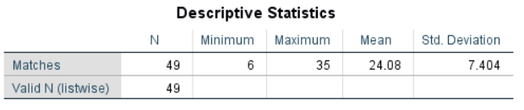

Z-test (1 Sample)

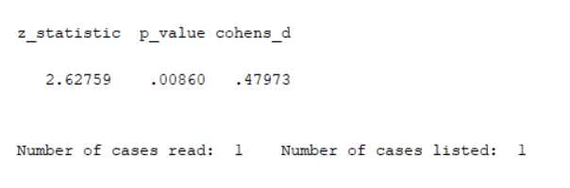

Conclusion:

At α = 0.05, the Critical Value in One-Sample Z-Test is 1.645. (Critical)

From the above Z-Test conducted using SPSS, the obtained/calculated value is 2.627. (Calculated)

As Calculated value > Critical Value, at 5% Level of Significance, there’s enough evidence to reject the claim that in a Sample of 30 Batsmen, the average matches played by an Individual is equal to the Average matches played by all 49 Batsmen in the Population.

___________________________________________________________________